**Inductor Design**

**Ferrite Cores**

Toroidal shape Ferrite core values have been examined as a starting point for designing the inductor for the buck converter with the specified rated values. One of the main properties of the ferrite cores is that their high permeability values, which increase flux density. Although it is quite easy to reach high inductor values with less winding, they have not been seen as a reasonable option in high current applications because of their low saturation flux density, which is generally around 0.5 T. According to the Formulas (5), since reducing the rated current is not an option and the radius value is limited by physical factors, the only option is to reduce the µ value to decrease operating flux density for allowing reasonable amount of N turns. Therefore, it has been considered appropriate to look at magnetic core materials with lower permeability and higher maximum flux density values. In case of ferrite core use, it has been decided to examine the changes in the case of including an air gap in the core design.

|  |  |  |
| --- | --- | --- |
|  |  | (5) |

**Iron Powder Cores**

Iron powder toroidal cores have much lower permeability and higher saturation flux density values comparing with the toroidal ferrite cores. When the variables seen in the equation (…) are evaluated, the permeability decreases can only be caused by the increase in the number of turns. Even though keeping B value seems to be as desired due to the saturation effect, it makes that very difficult to reach the required level of inductance. Therefore, the problem with iron powder cores is requiring high number of turns. On the other hand, while inductance is proportional with the square of N (number of turns), flux density is proportional with N. Therefore, higher inductance values can be achieved with increasing N without effecting B field as much as the ferrite core case, due to the effect of low permeability.

Magnetic permeability has been decreased to achieve stable operation in the designed inductance. However, it also affects inductance proportionally, which can be observed from Equation …. For this reason, the highest possible permeability values of iron cores have been evaluated considering their optimum operating conditions. As can be examined in the Figure …., although type 26 material have higher permeability, it is suitable for DC applications. Therefore, type 3 material have been chosen as core material due to its high permeability and ability to operate at 0.05-0.5 MHz frequencies.

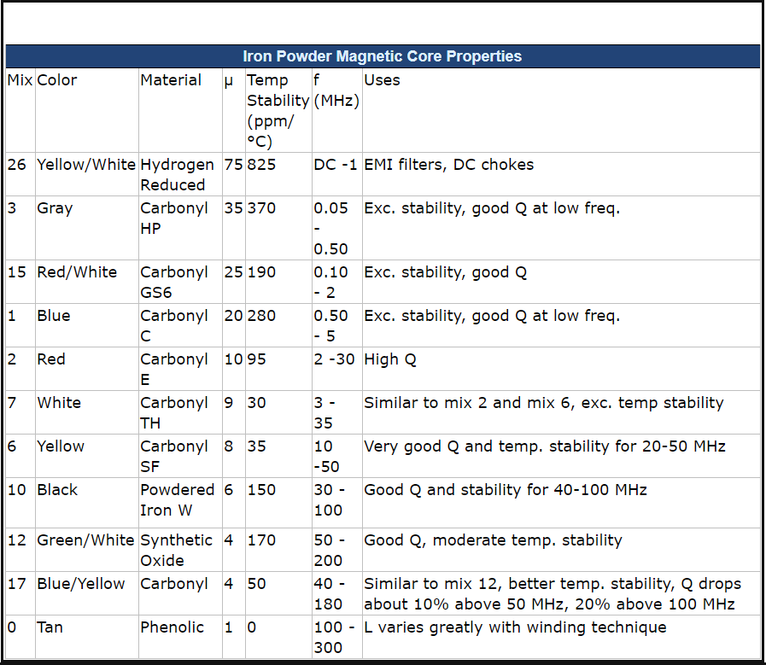

After the material selections, the required core size has been determined for the inductance value to be created. The AL values of the different size of powder iron cores have been given in Figure …, where AL represents the how much µH does these core sizes supposed to have for 100 turns. The equations given in (…) can be used to calculate the required number of turns for a specific inductor value. According to the calculations considering Al values given in Figure …, T106 size of type 3 powder iron core have been selected with 182 turns.

$$N=100* \sqrt{\frac{L}{A_{L}}}, L= A_{L}*\left(\frac{N^{2}}{{10}^{4}}\right)$$

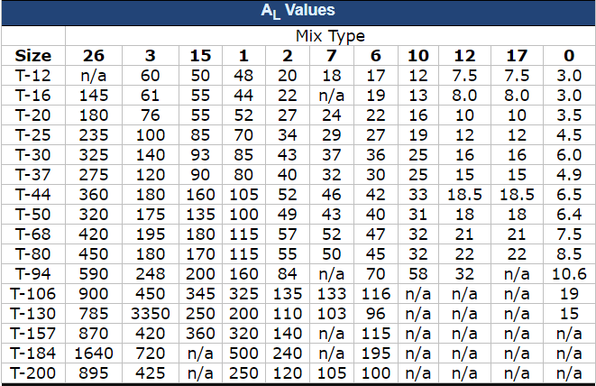

After the size and type selections are made, it should be ensured that the selected core can operate without any saturation in flux density. The recommendation of the manufacturer company Amidon for the use of ferrite and iron powder materials is as follows:

*“Saturation will decrease the permeability of the core causing it to have impaired performance or to become inoperative. The safe operation total flux density for most Ferrites is typically 2000 gauss, while the Iron Powders can tolerate up to 5000 gauss.”*

Flux density was found as 0.266 T in the calculation using equation 5. Considering this, it can be concluded that the designed inductor with the selected values is suitable for its intended use and will operate within the safe operation region.

**Cable**

The average and maximum current values passing through the inductor have been observed as 2 and 2.15 A respectively, Figure …. Therefore, the cable thickness to be used in the inductor windings have been chosen as 22 AWG (American Wire Gauge), which is able to carry 3A of current trough it at 60° with 0.644 mm thickness. Therefore, the main factor limiting the maximum current amount the inductor can carry is the thickness of the cable used. In the current design, the maximum current rating is set to 3A with 22 AWG cable thickness.

After finding the cable thickness, inductance value and the number of windings required to reach this inductance, it is time to calculate how much cable is spent for this number of windings. In this case, it has been found that a 7m 22 AWG coper cable is sufficient to wind 182 times around the selected core.

<http://www.amidoncorp.com/product_images/Amidon-Tech-Data-Flyer-v19.pdf>